December 18, 2019

To whom it may concern:

Donna Cori Gibson was invited to a weekend event in celebration of devotion to the Sacred Heart of Jesus for Billings Catholic Radio. At a previous event an attendee introduced me to her music and we immediately looked for an opportunity to bring Donna to Billings. As this event was going to be very prayerful and meditative, we knew she would be perfect to help set the tone of the weekend. We underestimated just how amazing her involvement would be.
Donna was wonderful to have perform selected music for our guests and her presentation of the Way of the Cross left no one untouched.
We continue to hear wonderful response from our attendees, and they all found Donna to be a perfect inclusion to their weekend.
I cannot think of a Catholic event where Donna would not be a wonderful addition or as a keynote speaker and/or performer.

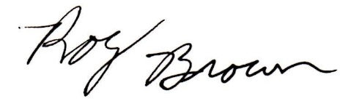

Roy Brown- Executive Director

